CALENDAR AND TIME NOTIFICATIONS

CALENDAR AND TIME NOTIFICATIONS
- The goal is have a popup message on boot that notifies the user of tasks that are due on that day

SHOW_TASKS_DUE_TODAY( )
- We'll create a function show_tasks_due_today( )
- We'll start by grabbing today's date with date.today( ).isoformat( )
- We'll iterate through our global tasks list and append each task that matches that matches the isoformat of today's date
  - NOTE that we use isoformat because that's how each task is saved in our JSON file
- We'll return if our list is empty
- We're going to use a messagebox for our popup
  - The message parameter within messagebox.showinfo( ) can be multiple lines long, and we'll use this feature to show all of our tasks that are due
- We'll create a variable to hold our placement string "Tasks due today:\n\n"
  - We'll iterate through our due tasks, and we'll customize our message for tasks that include a time, not just a date
- We'll ahve to use a helper function to reformat the time's isoformat
  - isoformat saves time as 24-hour time, and we want 12-hour time
  - We'll create a helper function that user datetime.strptime( ) to create a datetime object from our isoformat string and then we'll convert that object back into a string with our desired format
    - NOTE the paramters used for 24-hour time: %H:%M
    - NOTe that when we create a string from our newly created datetime object, we use .strip("0") – left strip – to strip any zeros from the left side remaining from 24-hour time
- We'll call the show_tasks_due_today( ) function right after load_tasks( ) at the beginning of the program to have this popup appear on boot
  - root.after( ) gives Tkinte rtime to full draw and focus the root window first. Then the messagebox can properly attach itself to the root window

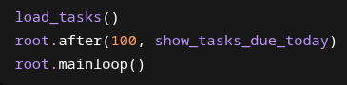

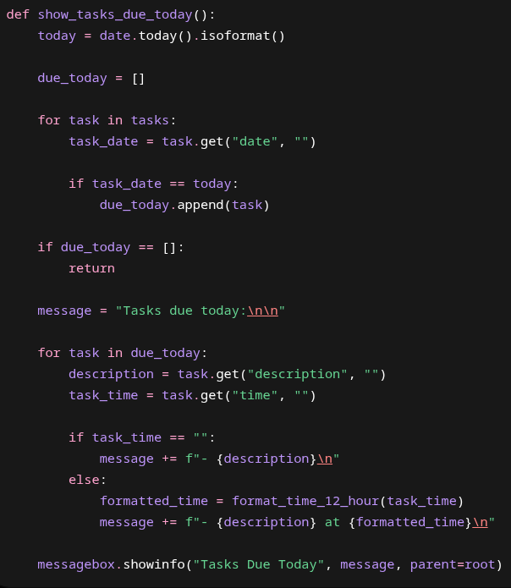

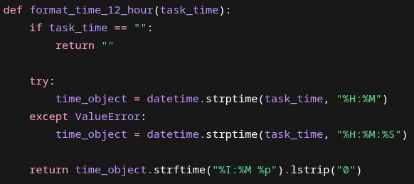

FULL CODE
import tkinter as tk
import json
import hashlib
import os
from datetime import datetime, date
from tkinter import simpledialog, messagebox
root = tk.Tk()
root.title("Task List")
root.geometry("500x450")
tasks = []
completed_tasks = 0
drag_start_index = None
TASKS_FILE = "tasks.json"
SALT_SIZE = 16
MASTER_PASSWORD = "generic_password"
def add_task_notes(description):
window = tk.Toplevel(root)
window.title("Task Details")
window.geometry("400x320")
window.transient(root)
window.grab_set()
window.focus_set()
tk.Label(window, text="Date:", font=("Arial", 12)).grid(row=0, column=0, sticky="e", padx=10, pady=8)
date_entry = tk.Entry(window, font=("Arial", 12))
date_entry.grid(row=0, column=1, padx=10, pady=8)
date_entry.focus_set()
tk.Label(window, text="Time:", font=("Arial", 12)).grid(row=1, column=0, sticky="e", padx=10, pady=8)
time_entry = tk.Entry(window, font=("Arial", 12))
time_entry.grid(row=1, column=1, padx=10, pady=8)
tk.Label(window, text="Notes:", font=("Arial", 12)).grid(row=2, column=0, sticky="ne", padx=10, pady=8)
notes_frame = tk.Frame(window)
notes_frame.grid(row=2, column=1, padx=10, pady=8)
notes_text = tk.Text(notes_frame, font=("Arial", 12), width=25, height=5)
notes_text.pack(side="left", fill="both", expand=True)
notes_scrollbar = tk.Scrollbar(notes_frame, command=notes_text.yview)
notes_scrollbar.pack(side="right", fill="y")
notes_text.config(yscrollcommand=notes_scrollbar.set)
def submit(event=None):
date_text = date_entry.get().strip()
time_text = time_entry.get().strip()
if date_text == "":
due_date_text = ""
else:
try:
due_date = datetime.strptime(date_text, "%m-%d-%Y").date()
due_date_text = due_date.isoformat()
except ValueError:
messagebox.showerror(
"Invalid Date",
"Please enter the date in this format:\n\n"
"Date: MM-DD-YYYY\n"
"Example: 05-11-2026",
parent=window
)
return
if time_text == "":
due_time_text = ""
else:
try:
due_time = datetime.strptime(time_text, "%I:%M %p").time()
due_time_text = due_time.isoformat()
except ValueError:
messagebox.showerror(
"Invalid Time",
"Please enter the time in this format:\n\n"
"Time: HH:MM AM/PM\n"
"Example: 04:30 PM",
parent=window
)
return
task = {
"description": description,
"date": due_date_text,
"time": due_time_text,
"notes": notes_text.get("1.0", tk.END).strip()
}
tasks.append(task)
task_listbox.insert(tk.END, description)
save_tasks()
task_entry.delete(0, tk.END)
window.destroy()
submit_button = tk.Button(window, text="Create Task", font=("Arial", 12), command=submit)
submit_button.grid(row=3, column=1, pady=15)
window.bind("<Return>", submit)
def add_task(event=None):
description = task_entry.get()
if description == "":
return
add_task_notes(description)
def create_key(password, salt):
password_bytes = password.encode()
combined = password_bytes + salt
key = hashlib.sha256(combined).digest()
return key
def delete_task(event=None):
selected = task_listbox.curselection()
if selected == ():
return
index = selected[0]
task_listbox.delete(index)
tasks.pop(index)
save_tasks()
def drag_task(event):
global drag_start_index
new_index = task_listbox.nearest(event.y)
if drag_start_index is None:
return
if new_index == drag_start_index:
return
task = tasks.pop(drag_start_index)
tasks.insert(new_index, task)
refresh_listbox()
task_listbox.selection_set(new_index)
drag_start_index = new_index
def format_time_12_hour(task_time):
if task_time == "":
return ""
time_object = datetime.strptime(task_time, "%H:%M")
return time_object.strftime("%I:%M %p").lstrip("0")
def load_encrypted_data(filename, password):
with open(filename, "rb") as file:
file_data = file.read()
salt = file_data[:SALT_SIZE]
encrypted_bytes = file_data[SALT_SIZE:]
key = create_key(password, salt)
decrypted_bytes = xor_data(encrypted_bytes, key)
json_text = decrypted_bytes.decode()
data = json.loads(json_text)
return data
def load_tasks():
global tasks
global completed_tasks
try:
data = load_encrypted_data(TASKS_FILE, MASTER_PASSWORD)
tasks = data.get("tasks", [])
completed_tasks = data.get("completed_tasks", 0)
for task in tasks:
task_listbox.insert(tk.END, task.get("description", ""))
except FileNotFoundError:
tasks = []
completed_tasks = 0
except UnicodeDecodeError:
tasks = []
completed_tasks = 0
print("Could not decrypt file. Wrong password or corrupted file.")
except json.JSONDecodeError:
tasks = []
completed_tasks = 0
print("Could not load JSON. Wrong password or corrupted file.")
def mark_completed():
global completed_tasks
selected = task_listbox.curselection()
if selected == ():
return
index = selected[0]
task_listbox.delete(index)
tasks.pop(index)
completed_tasks += 1
save_tasks()
update_counter()
def open_task_notes(event=None):
selected = task_listbox.curselection()
if selected == ():
return
index = selected[0]
task = tasks[index]
window = tk.Toplevel(root)
window.title("Edit Task Notes")
window.geometry("430x360")
window.transient(root)
window.wait_visibility()
window.focus_set()
window.grab_set()
tk.Label(window, text="Task:", font=("Arial", 12)).grid(
row=0, column=0, sticky="e", padx=10, pady=8
)
description_entry = tk.Entry(window, font=("Arial", 12), width=28)
description_entry.grid(row=0, column=1, padx=10, pady=8)
description_entry.insert(0, task.get("description", ""))
tk.Label(window, text="Date:", font=("Arial", 12)).grid(
row=1, column=0, sticky="e", padx=10, pady=8
)
date_entry = tk.Entry(window, font=("Arial", 12), width=28)
date_entry.grid(row=1, column=1, padx=10, pady=8)
tk.Label(window, text="Time:", font=("Arial", 12)).grid(
row=2, column=0, sticky="e", padx=10, pady=8
)
time_entry = tk.Entry(window, font=("Arial", 12), width=28)
time_entry.grid(row=2, column=1, padx=10, pady=8)
date_text = task.get("date", "")
time_text = task.get("time", "")
if date_text != "":
due_date = datetime.strptime(date_text, "%Y-%m-%d").date()
date_entry.insert(0, due_date.strftime("%m-%d-%Y"))
if time_text != "":
due_time = datetime.strptime(time_text, "%H:%M:%S").time()
time_entry.insert(0, due_time.strftime("%I:%M %p"))
tk.Label(window, text="Notes:", font=("Arial", 12)).grid(
row=3, column=0, sticky="ne", padx=10, pady=8
)
notes_frame = tk.Frame(window)
notes_frame.grid(row=3, column=1, padx=10, pady=8)
notes_text = tk.Text(notes_frame, font=("Arial", 12), width=25, height=6)
notes_text.pack(side="left", fill="both", expand=True)
notes_scrollbar = tk.Scrollbar(notes_frame, command=notes_text.yview)
notes_scrollbar.pack(side="right", fill="y")
notes_text.config(yscrollcommand=notes_scrollbar.set)
notes_text.insert("1.0", task.get("notes", ""))
def save_changes(event=None):
date_text = date_entry.get().strip()
time_text = time_entry.get().strip()
if date_text == "":
due_date_text = ""
else:
try:
due_date = datetime.strptime(date_text, "%m-%d-%Y").date()
due_date_text = due_date.isoformat()
except ValueError:
messagebox.showerror(
"Invalid Date",
"Please enter the date in this format:\n\n"
"Date: MM-DD-YYYY\n"
"Example: 05-11-2026",
parent=window
)
return
if time_text == "":
due_time_text = ""
else:
try:
due_time = datetime.strptime(time_text, "%I:%M %p").time()
due_time_text = due_time.isoformat()
except ValueError:
messagebox.showerror(
"Invalid Time",
"Please enter the time in this format:\n\n"
"Time: HH:MM AM/PM\n"
"Example: 04:30 PM",
parent=window
)
return
task["description"] = description_entry.get()
task["date"] = due_date_text
task["time"] = due_time_text
task["notes"] = notes_text.get("1.0", tk.END).strip()
refresh_listbox()
task_listbox.selection_set(index)
save_tasks()
window.destroy()
save_button = tk.Button(
window,
text="Save Changes",
font=("Arial", 12),
command=save_changes
)
save_button.grid(row=4, column=1, pady=15)
window.bind("<Return>", save_changes)
def refresh_listbox():
task_listbox.delete(0, tk.END)
for task in tasks:
task_listbox.insert(tk.END, task["description"])
def save_encrypted_data(data, filename, password):
json_text = json.dumps(data)
json_bytes = json_text.encode()
salt = os.urandom(SALT_SIZE)
key = create_key(password, salt)
encrypted_bytes = xor_data(json_bytes, key)
with open(filename, "wb") as file:
file.write(salt + encrypted_bytes)
def save_tasks():
data = {
"completed_tasks": completed_tasks,
"tasks": tasks
}
save_encrypted_data(data, TASKS_FILE, MASTER_PASSWORD)
def show_tasks_due_today():
today = date.today().isoformat()
due_today = []
for task in tasks:
task_date = task.get("date", "")
if task_date == today:
due_today.append(task)
if not due_today:
return
message = "Tasks due today:\n\n"
for task in due_today:
description = task.get("description", "")
task_time = task.get("time", "")
if task_time == "":
message += f"- {description}\n"
else:
formatted_time = format_time_12_hour(task_time)
message += f"- {description} at {formatted_time}\n"
messagebox.showinfo("Tasks Due Today", message, parent=root)
def start_drag(event):
global drag_start_index
drag_start_index = task_listbox.nearest(event.y)
def stop_drag(event):
save_tasks()
def update_counter():
counter_label.config(text=f"Tasks Completed: {completed_tasks}")
def update_counter_manual():
global completed_tasks
new_total = simpledialog.askinteger(
"Update Completed Tasks",
"Enter the number you want the running total to be:",
parent=root
)
if new_total is None:
return
completed_tasks = new_total
save_tasks()
update_counter()
def xor_data(data, key):
result = bytearray()
for i in range(len(data)):
key_index = i % len(key)
new_byte = data[i] ^ key[key_index]
result.append(new_byte)
return bytes(result)
task_listbox = tk.Listbox(root, font=("Arial", 14), width=40, height=10)
task_listbox.pack(pady=10)
task_listbox.bind("<Button-1>", start_drag)
task_listbox.bind("<B1-Motion>", drag_task)
task_listbox.bind("<ButtonRelease-1>", stop_drag)
task_listbox.bind("<Double-Button-1>", open_task_notes)
load_tasks()
root.after(100, show_tasks_due_today)
task_entry = tk.Entry(root, font=("Arial", 14))
task_entry.bind("<Return>", add_task)
task_entry.pack(pady=10)
task_entry.focus_set()
button_frame = tk.Frame(root)
button_frame.pack(pady=5, fill="x", padx=40)
delete_button = tk.Button(button_frame, text="Delete Task", font=("Arial", 12), command=delete_task)
delete_button.pack(side="left", padx=5)
add_button = tk.Button(button_frame, text="Add Task", font=("Arial", 12), command=add_task)
add_button.pack(side="left", padx=5)
mark_button = tk.Button(button_frame, text="Mark Completed", font=("Arial", 12), command=mark_completed)
mark_button.pack(side="left", padx=10)
counter_frame = tk.Frame(root)
counter_frame.pack(pady=10)
counter_label = tk.Label(counter_frame, text=f"Tasks Completed: {completed_tasks}", font=("Arial", 14))
counter_label.pack(side="left", padx=5)
update_counter_button = tk.Button(counter_frame, text="Update", font=("Arial", 12), command=update_counter_manual)
update_counter_button.pack(side="left", padx=5)
root.bind("d", delete_task)
root.mainloop()

